Pregunta 1
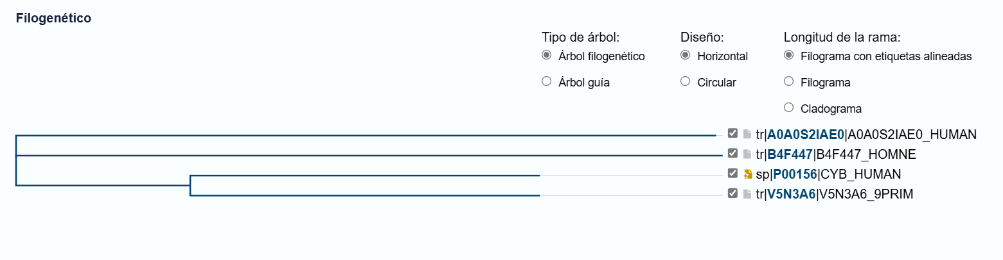
Pregunta 4
Sequence:
Met-Pro-Lys-Leu-Ile-Asp-Phe-Ser-Trp-Thr-Ala-Leu-Asn-Ala-Glu

Hydrophobic (H): Met, Pro, Leu, Ile, Phe, Trp, Ala, Leu, Ala
Polar (P): Lys, Asp, Ser, Thr, Asn, Glu
Hydrophobic (H): M, P, L, I, F, W, A, L, A
Polar (P): K, D, S, T, N, E

Sequence classified as HP:
H-P-P-H-H-P-H-P-H-P-H-H-P-H-P
H at (0, 0)
Pro (P): P at (0, 1)
Lys (K): P at (0, 2)
Leu (L): H at (0, 3)
Ile (I): H at (1, 3)
Asp (D): P at (2, 3)
Phe (F): H at (2, 2)
Ser (S): P at (1, 2)
Trp (W): H at (1, 1)
Thr (T): P at (1, 0)
Ala (A): H at (2, 0)
Leu (L): H at (3, 0)
Asn (N): P at (3, 1)
Ala (A): H at (3, 2)
Glu (E): P at (3, 3)

(0, 0) H (Met)
(0, 1) P (Pro)
(0, 2) P (Lys)
(0, 3) H (Leu)
(1, 3) H (Ile)
(2, 3) P (Asp)
(2, 2) H (Phe)
(1, 2) P (Ser)
(1, 1) H (Trp)
(1, 0) P (Thr)
(2, 0) H (Ala)
(3, 0) H (Leu)
(3, 1) P (Asn)
(3, 2) H (Ala)
(3, 3) P (Glu)

Resultado
(-1, -1) P P H
(0, -1) H P H
(1, -1) P H P
(2, -1) H P H

Pregunta 8
